**School of Electrical**

**and Electronic Engineering**



**Robot Orchestra**

**Final Report**

**Group 11**

|  |  |  |
| --- | --- | --- |
| Group Members: | Buruiana, Andrei | 9478411 |
|  | Chanda, Joyanto | 9015629 |
|  | Dimou, Theodoros | 9126435 |
|  | Fumagalli, Francesco | 9017237 |
|  | Petrovs, Antons | 9474345 |
|  | Simpson, Joshua | 8929879 |

Tutors: Prof. Danielle George and Dr. William McGenn

Date: 15 May 2018

Table of Contents

1. Heading 1 3

1.1. Heading 2 3

1.1.1. Heading 3 3

1.1.2. Bullet points 3

2. References 4

(delete these 2 pages)

# Keyboard

## Why Keyboard

The keyboard was chosen as an instrument due to flexibility it provides the orchestra to play a wide range of notes. The following sections will first summarise the main components of the keyboard and then describe the design decisions made in the design. The overall specification for the keyboard is that it should be able to:

* play the tracks chosen for the keyboard from the three selected pieces of music.
* communicate with the conductor so it can be controlled alongside the other instruments
* be transportable

## Overall design description

Figure 2.1 shows the keyboard Design. The robot keyboard design uses solenoids to press the keys and a Teensy microcontroller board to control the instrument. The solenoids are supported by a Bosch bar and are connected to the Bosch bar using threaded rods, which are split into two different lengths: 60mm and 105mm for the white and black keys respectively. The solenoids attach to the threaded rod using a bracket made from clear Perspex, allowing the solenoid to be positioned at any point along the rod and allow it to be adjusted vertically by 25mm. The Bosch bar has a threaded rod at each end to support it, so its position above the keyboard is adjustable. The PCBs to control the solenoids are mounted on a Perspex plate that is attached to the Bosch bar. There are only 25 solenoids set up these cover the notes required for the three chosen test tracks (see appendix??? for table). This decision was made to keep in the project budget of £1500 as each solenoid costs £10.40 so to have 25 is a cost of £260. It would have cost £634.40 to outfit the entire keyboard, which would have been about 42% of the projects budget. The instrument has been designed, so in the future more solenoids to cover the full range of notes can be easily added. For the time being, if when expanding the range of songs to be played by the orchestra the notes required are outside the range of the solenoids set up, the notes can be shifted by an octave into the notes played by the keyboard without too much effect on the sound of the music. The design can be dismantled the threaded rods unscrew from the Bosch bar and the base plates meaning it can be transported in a … box.

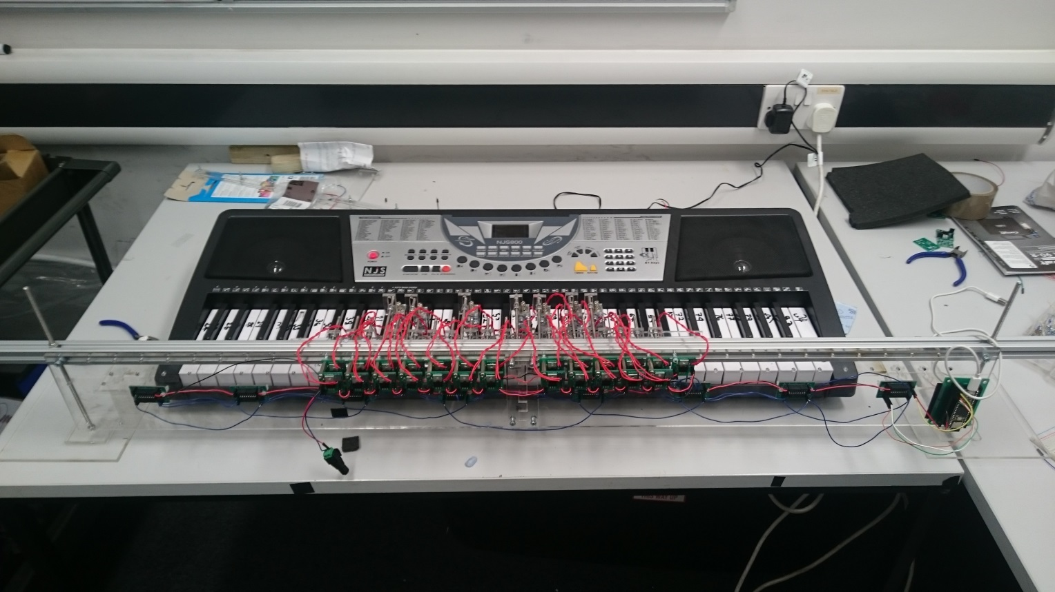

Threaded rod supports with base plate

Shift register PCB

Solenoid switching Transistor PCB

Solenoids and brackets

Bosch Bar

Teensy Embedded system

Figure .: Keyboard instrument

## Solenoid Selection

Firstly, a test was carried out to find the force needed to cause the keys to play a note the table is given in appendix. A mass of 70g is required to press down allowing using a safety factor of 25% the keys need a force of 1.5*0.070g*9.81m/s^2=1.03N=105gf to be pressed. The distance the key needs to be depressed is 3mm so the solenoid throw needs to be at least 3mm. In the music chosen up to 4 keys can be played at the same time so the solenoid also needs a low current demand so they can be powered using an off the shelf plug. The 12V 3W SD0630 fulfils these requirements it can provide 120gf with a duty cyle of 50% (none of the songs require any one note to be depressed 50% of the time (table to prove)). It also has a throw of 10mm and has a current requirement of 0.25A so 8 could be pressed at once using a 12V 2A supply (datasheet in appendix…).

One solenoid was bought to test. The solenoid came without a stopper so one was printed in the mechanical workshop with the design shown in Apendix this was a allows the solenoid throw to be adjusted so it was decided this was a positive feature. The solenoid was tested and it was able to press the white and black keys. The main issue with the solenoid was the clicking made when the solenoid switches on and off. This was partially solved by putting foam between the stopper and the solenoid as shown in figure.

Another clicking sound was made when the plunger hits the inside of the solenoid. An attempt was made to lessen this as well by putting a small piece of foam on the plunder figure?. However, this caused issues as it added extra resistance to the working of the solenoid so, it re-acted slower when turning on and caused different delays between each solenoid. It was decided this would cause issues with playing the songs and synchronisation of the instruments so the foam was removed. The volume of the keyboard can be turned up to a level that mitigates the sound of the clicking and the clicking dose give the instrument a mechanical sound which actually fits in with the aesthetic of the orchestra.

## Supporting the Solenoids

To make the construction of the rail supporting the solenoids flexible a Bosch bar was used as it allows the solenoids to be placed at any point along its length. This is achieved using T-slot nuts to secure the threaded rod in the Bosch bar to which the solenoids can be attached. The threaded rods will be 4mm in diameter as the T-slot nuts are M4.

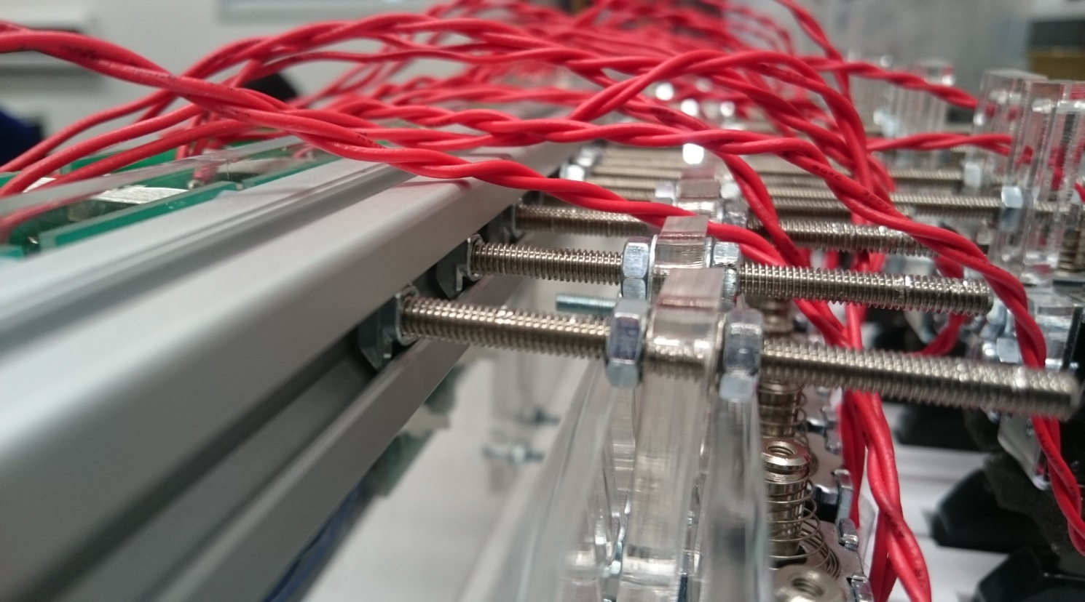

T-slot nut

Threaded rod

Bracket

solenoid

Bosch Bar

A bracket was required to connect the solenoid to the threaded rod. This needed to be easily adjustable so the solenoid could be put into the correct position. It also had to be limited in width as the keyboard is 726mm long with 36 white keys which leaves 20.16mm per key for the bracket. However, space for a 4mm rod also has to be left for rods to pass through to the black keys leaving 16mm. The the width of the solenoids is …..

The design went through several iterations. The first design is shown in figure it allows for vertical movement but not movement along the length threaded rods therefore, the rods would have to be made to the exact length and it wouldn’t be adjustable. The next design is in figure this allows for horizontal and vertical movement (25mm) the design is stepped so the threaded rod doesn’t interfere with the solenoid plunger. The third design just adjusted the distance between the step so there was a 2mmm difference between each side which makes it easier to overlap them in the mounting process.

## Solenoid PCB design

A transistor PCB was designed to turn the solenoid on and off. The required current for the solenoid is 0.25A. The instrument uses shift registers to deliver all the notes to the keyboard at the same time. The shift registers ate powered using one pin from the Teensy which can provide 25mA. If a worse case of 8 keys pressed at the same time is taken the current is 25/8=3.125mA. therefore the minimum gain required from the transistor is 0.25/3mA=83.3. It was decided to use the same transistor for the xylophone solenoids so only one type of transistor needed to be ordered and the same circuit could be used for both. The xylophone solenoid requires 2A and the Myrio can provide 150mA per digital output so the gain needed is 13.3. The decision was made to use the BJT, TIP120 which can handle 60V 5A and can provide a gain of 1000. This resistor required for the keyboard to provide the gain is ?? the circuit and PCB design are shown in figure.

## Supporting the Bosch Bar

It was decided to support the Bosch bar using two threaded rods located at either end as shown in Figure 2.1 which allows the solenoid rail to be adjusted vertically. The threaded rods were set at 230mm long this allows for the key height of 70mm, the 20mm thickness of the Bosch bar, 80mm for the solenoid and leaving 70mm to allow the rail to be moved upwards and remain supported while, the keyboard is removed from under the solenoid rail. A 5mm threaded rod was chosen as the Bosch bar has a 5mm gap in its design to attach the thread rod through.

A base plate was needed to hold the threaded rods vertically. It was decided to use Perspex for the various brackets and supporting plates for the instrument. So to keep in with the aesthetics of the design Clear Perspex was used for the support. The design is shown in figure and uses a two Perspex pieces one for which the threaded rod is attached using two nut which clamp the Perspex tight to the threaded rod. The second piece is glued to the other so the holes overlap allowing the lower nut clamping the other plate to be counter sunk into the base so the base can be flush with the surface its placed on. An M5 nut is 3.5mm thick and 9mm wide so the Perspex needs to be thicker than 3.5 and the hole needs to be at least 10mm. The laser cutter in the workshop can only cut 1cm thick Perspex and 5mm was the maximum thickness the workshop has in stock. So, it was decided to buy a 600mm by 600mm sheet of Perspex from the workshop for £40 as it could be used for all the other Perspex laser cutting needed. There is a channel running the length of the keyboard in which a bar can be run to connect the two Perspex stands together this is … away from the edge of the keyboard and the stands need to be located … away from the keyboard. So the larger base plate for the nut to be counter sunk into was made 150mm by 150mm with the centre of the 10mm hole 50mm in from each edge. The top plate which clamps the rod in place was 60x60mm with a 5mm hole in the centre.

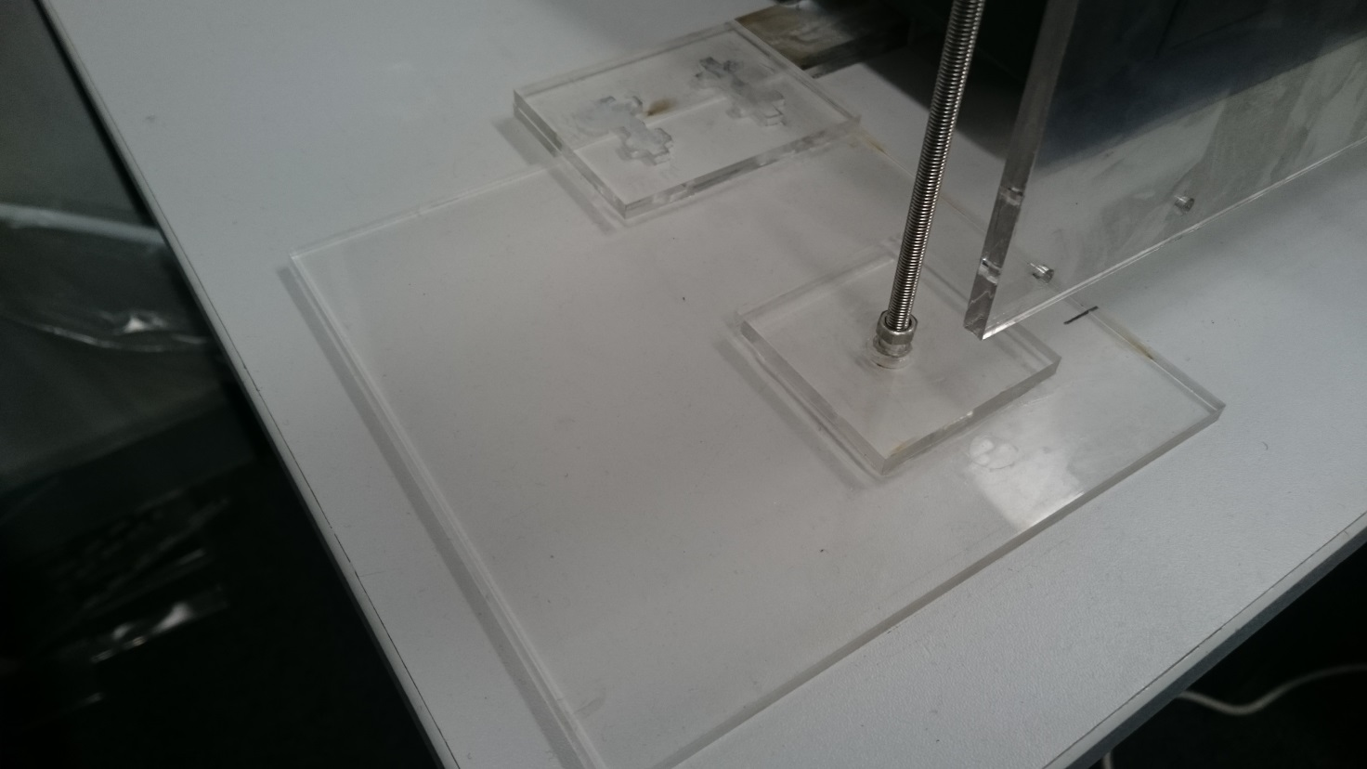

Large Base plate

Plate clamped to threaded rod with two nuts

Connection to the Perspex bar that connects both feet each end of the Bosch bar

Threaded rod

Large Base plate

Threaded rod

To remove the chance of the supports moving while the keyboard is playing a bar connecting the two stands was designed. To do this a channel that runs the length of the keyboard was utilised. The channel is 29mm wide and 20mm high. A Perspex rod was designed to run along it to attach to the two base plates at either end. The design used two lengths of Perspex each 29mmx550mm long that were attached in the middle using a 29x60mm plate to overlap the two pieces so they could be glued together. It was done in two sections, as the laser cutter cannot cut pieces longer than 600mmm long. The bar was then attached to the two supports using a overlapping ….x…. plate at either end to glue the pieces together. Two stopper pieces of perspex were made to stop the keyboard sliding along the bar the design is shown in figure. This means the solenoid rail is held in place by the keyboard.

## PCB Support Plate

There are 8 shift registers, 25 transistor and 1 Teensy PCB that need to be mounted on a perspec plate. The keyboard instrument is designed is so that it can be expanded to have solenoids for all the keys so space has been left on the plate for more transistor PCBs . The plate can be ...long and …. Wide. To do this in the required space the transistor PCBs have to be mounted as a double layer as shown in figure. They are mounted at the top of the plate so the solenoids leads which are … long can reach the PCBs. The shift registers are mounted below these in the middle of 8 solenoids so they can be easily wired up and the teensy is located at the end as it only needs wiring to the first shift register. The design for the plate is in Appendix 1.

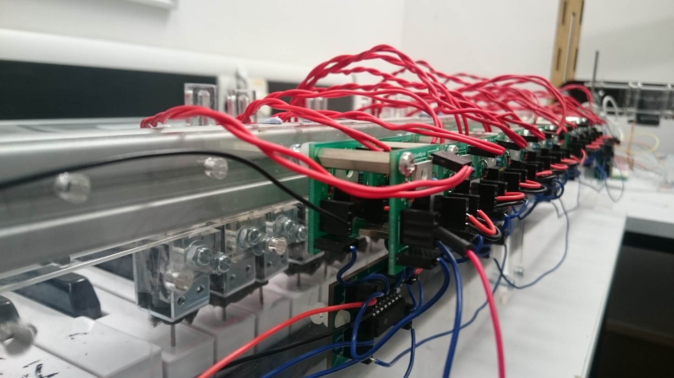

Appendix Keyboard

|  |  |
| --- | --- |
| Mass (g) | Did the key play? |
| 5 | No |
| 10 | No |
| 20 | No |
| 30 | No |
| 40 | No |
| 50 | No |
| 60 | No |
| 70 | Yes |
| 80 | Yes |
| 90 | Yes |
| 100 | Yes |

|  |  |  |  |  |
| --- | --- | --- | --- | --- |
| Notes Requird | | |  |  |
| Califonication | Eye of Tiger | Game of Thrones | Note count | Type of Key |
| 40 | 40 | 40 | 1 | w |
| 41 | 41 | 41 | 2 | w |
| 43 | 43 | 43 | 3 | w |
|  | 44 |  | 4 | b |
| 45 |  | 45 | 5 | w |
|  | 46 |  | 6 | b |
| 47 |  | 47 | 7 | w |
| 48 | 48 | 48 | 8 | w |
| 50 | 50 | 50 | 9 | w |
|  | 51 |  | 10 | b |
| 52 | 52 | 52 | 11 | w |
| 53 | 53 | 53 | 12 | w |
| 55 | 55 | 55 | 13 | w |
|  | 56 |  | 14 | b |
| 57 |  | 57 | 15 | w |
|  | 58 |  | 16 | b |
| 59 |  | 59 | 17 | w |
| 60 | 60 | 60 | 18 | w |
| 61 |  | 61 | 19 | b |
| 62 | 62 | 62 | 20 | w |
|  | 63 |  | 21 | b |
| 64 |  | 64 | 22 | w |
| 65 | 65 | 65 | 23 | w |
| 67 | 67 | 67 | 24 | w |
| 69 |  | 69 | 25 | w |

# References

[1] BBC, “BBC Radio 1 - Can a robot replace Ed Sheeran?,” BBC, 3 March 2017. [Online]. Available: <http://www.bbc.co.uk/programmes/p04sxvgw> [Accessed October 2017].

[2] L. Mather, “Glock o Bot,” YouTube, 13 June 2016. [Online]. Available: <https://www.youtube.com/watch?v=4toW8Tc9GPI> [Accessed October 2017].

[3] National Instruments, “Student Project Sponsorship - National Instruments United Kingdom,” National Instruments, 12 August 2017. [Online]. Available: <http://uk.ni.com/studentsponsorship> [Accessed November 2017].

[4] The editors of Encyclopedia Britannica. (2012). *Idiophone*. [Online] Available at: <https://www.britannica.com/art/idiophone> [Accessed November 2017].